What is Project Management?
Introduction
Project management is the structured process of planning, organizing, and controlling resources to achieve specific goals within a defined timeline. It ensures that a project is completed on time, within budget, and meets the expected quality standards. Whether it’s constructing a building, developing software, or launching a new product, project management provides the framework to turn ideas into reality.

Key Elements of Project Management
- Scope – Defines what the project will deliver and what is outside its boundaries.
- Time – Ensures tasks and milestones are completed within the scheduled deadlines.
- Cost – Manages the budget by balancing resources, labor, and expenses.
- Quality – Maintains standards to meet client and stakeholder expectations.
- Resources – Involves assigning people, equipment, and materials efficiently.
- Risk – Identifies uncertainties and prepares strategies to minimize their impact.

Phases of a Project
Project management typically follows five phases, known as the Project Life Cycle:
- Initiation – Defining the project’s purpose, goals, and feasibility.
- Planning – Creating detailed schedules, budgets, and resource allocations.
- Execution – Carrying out the actual work according to the plan.
- Monitoring & Controlling – Tracking progress, resolving issues, and adjusting as needed.
- Closure – Delivering the final output, reviewing performance, and formally closing the project.

Why is Project Management Important?
- Provides clarity and direction for teams.
- Improves efficiency by reducing wasted time and effort.
- Enhances communication among stakeholders.
- Minimizes risks and unexpected challenges.
- Increases the chances of project success.

Constraints in Project Management
Introduction:
In project management, building a reliable schedule is both an art and a science. While task dependencies and resource allocations provide a logical structure, they don’t always reflect the real-world conditions under which projects operate. That’s where constraints come in. They can have a powerful impact on how a project is managed, for better or worse.
Types of Constraints in Projects
- Flexible Constraints (default type)
Allow maximum flexibility : adjusts tasks based on links and calendars.

Examples:
As Soon As Possible (ASAP) (default in forward-scheduled projects)
As Late As Possible (ALAP) (default in backward-scheduled projects)
- Semi-Flexible Constraints
Task must start or finish no earlier/later than a certain date.
Examples:
    - Start No Earlier Than (SNET)
    - Start No Later Than (SNLT)
    - Finish No Earlier Than (FNET)
    - Finish No Later Than (FNLT)
- Inflexible (Hard) Constraints
Fixes a task to a specific date, regardless of dependencies.
Examples:
    - Must Start On (MSO)
    - Must Finish On (MFO)

When to Use Constraints
- SNET/FNET → If a task can only start/finish after a certain date (e.g., waiting for material delivery).
- SNLT/FNLT → If a deadline forces a task to start/finish before a certain date.
- MSO/MFO → If a task must occur on an exact date (e.g., client inspection, project launch).
Knowledge areas in Project Management
Introduction
In Project Management (PMBOK – Project Management Body of Knowledge), there are 10 Knowledge Areas that form the foundation for managing projects effectively. Each area focuses on a specific aspect of project management and is interconnected with the others.
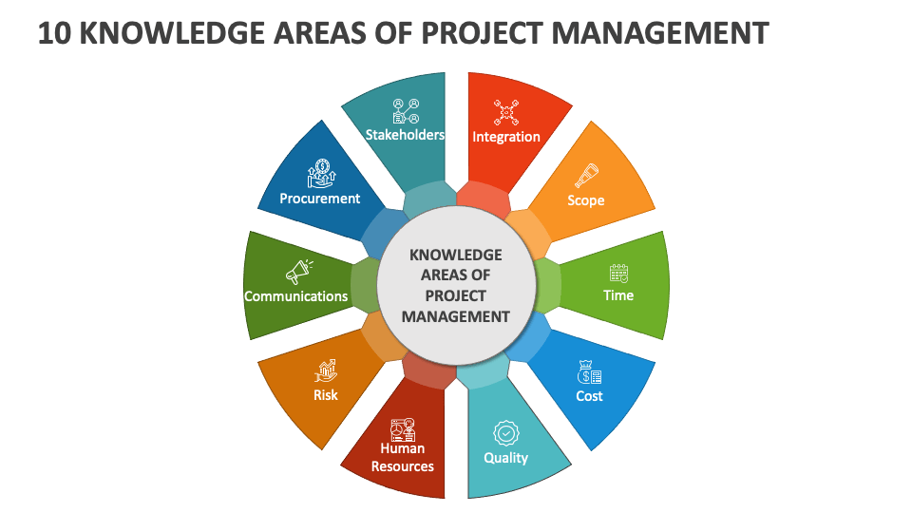
1. PROJECT INTEGRATION MANAGEMENT
Process to identify and coordinate the various project management activities within the project management process
2. PROJECT SCOPE MANAGEMENT
Includes the process required to ensure that the project includes all work required to complete the project successfully
3.PROJECT TIME MANAGEMENT
Includes the process required to manage timely completion of project
4. PROJECT COST MANAGEMENT
It includes the processes involved in planning, estimating, budgeting, financing, funding, managing and controlling costs so that the project can be completed within approved budget
5. PROJECT QUALITY MANAGEMENT
It includes processes and activities that determine quality policies, objectives and responsibilities so that the project will satisfy the needs for which it was undertaken
6. PROJECT HUMAN RESOURCE MANAGEMENT
•It includes the processes that organize , manage and lead the project team.
•The project team includes people with assigned roles and responsibilities for completing the project.
7. PROJECT COMMUNICATION MANAGEMENT It includes the processes that are required to ensure timely and appropriate planning, collection creation, distribution, storage, management, control, monitoring and the ultimate disposition of project information
8. PROJECT RISK MANAGEMENT
It includes the processes of conducting risk management planning, identification, analysis and controlling risks on a project
9. PROJECT PROCUREMENT MANAGEMENT
It is necessary to purchase or acquire products, services or results needed from outside of the project team
10. PROJECT STAKEHOLDER MANAGEMENT
It includes the process involved to identify the people, groups or organization that could impact or be impacted by the project.
Resource Analysis in Project Management
Introduction:
Resourse Analysis & Levelling is a technique used to balance the resource work load by adjusting the duration of the activities or working hours of a resource. If the resource assigned units is greater than resource maxiumum unit it causes resource overallocation , The method used to solve the over allocation is called Resource leveling techniques.
This process is all about ensuring that the resources (people, equipment, materials) assigned to activities are utilized effectively without overloading them, while keeping the project timeline realistic.
In Microsoft Project, Resource Analysis helps project managers to:
- Identify overallocation (when a resource is assigned more work than its available capacity).
- Detect underutilization (when resources are not being used to their full potential).
- Check availability and workload distribution across the project timeline.
- Forecast bottlenecks that may cause project delays.
- Support better decision-making for reassigning or redistributing resources.
What causes Resource Overallocation?
There are two Tasks Activity A & Activity B which is starting on same day , when a resource is assigned for these two tasks same time then the working hours of this resource will be more than the available units. Project Management software like MS Project use the indicator to show resource overallocation as shown in image below.
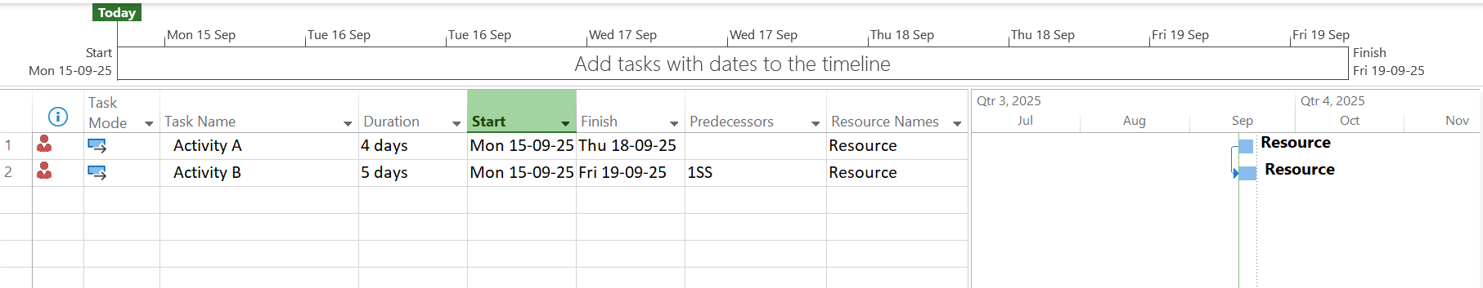
Resource Over allocation Indicator in Activity view

Resource Graph to analyze Overallocation:
Microsoft Project uses a Resource Graph view which shows the workload and resource assignment. This graph is generated with Time scale v/s Resource assignment unit.
The overallocated Resources are indicated by red color & Underallocated resource is indicated in blue color as shown below.
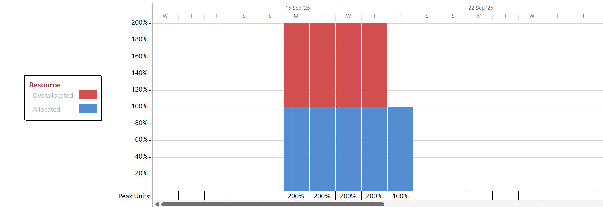
Resource Graph indicating over allocation

Methods to Solve Resource Allocation in MS Project:
Introduction
Effective resource allocation is one of the biggest challenges in project management. Assigning the right people, equipment, or materials to the right tasks at the right time ensures smooth project execution. However, when multiple tasks compete for the same resources, over allocations can occur—leading to delays, cost overruns, and poor productivity.
Resource Levelling Techniques:
1. Resource Smoothing (Using Slack)
Smoothing is about adjusting tasks within available slack without changing the project finish date. By setting leveling options to restrict adjustments only within slack, MSP ensures resources are balanced while deadlines remain unaffected.
2. Adjusting Resource Assignment
In this method the activity relationship can be changed which will cause the delay of the activity end dates
Example : Instead of starting both activity on same date we can change the linking of the task to FS(Finish to start) which will delay the acticities and remove the over allocation.
3. Splitting Tasks
MS Project allows splitting tasks into smaller segments. This means a resource can work on a task intermittently while also handling other assignments, avoiding resource overload.
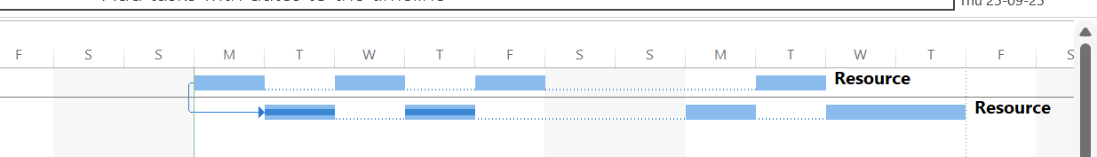
Activity Split view

4. Delaying Tasks Manually
Project managers can manually delay tasks using Task Information → Advanced → Delay or by dragging tasks in the Gantt chart. This provides control over when resources work, though delaying critical tasks may extend project duration.

5. Changing Task Types
Tasks in MSP can be set as Fixed Duration, Fixed Units, or Fixed Work. By changing task type, MSP automatically adjusts other parameters to balance resources.

6. Assigning Additional Resources.
If we match the peak unit with the maximum unit then over allocation will be solved automatically as shown in Picture below.
7. Using Resource Pools
For organizations managing multiple projects, MS Project offers Resource Pools. A shared resource pool ensures that resources are not overloaded across parallel projects, giving managers a unified view of availability.
Conclusion
Effective project management is the art of transforming vision into measurable results through structured planning, disciplined execution, and strategic control. By integrating key knowledge areas—such as scope, schedule, cost, quality, and risk—organizations can achieve both efficiency and excellence. Tools like Microsoft Project further empower managers to balance constraints, optimize resources, and maintain adaptability amid real-world challenges. When applied thoughtfully, these principles ensure that projects are not only completed on time and within budget but also deliver sustainable value, meet stakeholder expectations, and contribute to long-term organizational success.

